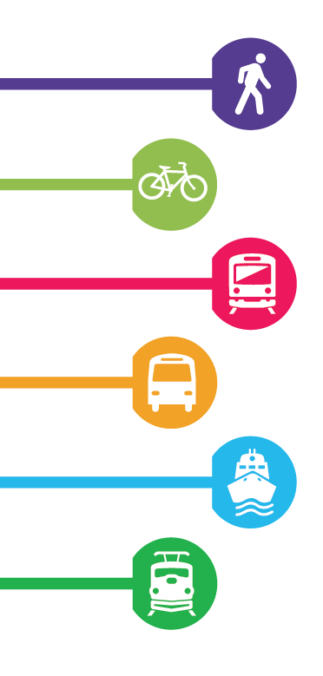
Supporting public transit
Supporting public transit
Written submission for the pre-budget consultations in advance of Budget 2023
Canadian Urban Transit Association
January 30, 2023
Recommendation 1: Provide operating support for public transit as ridership returns to pre-pandemic levels.
We applaud the fact that public transportation is valued at all levels of government and is recognized for its benefits. It provides Canadians with affordable transportation options and ensures more equitable economic growth. It offers an opportunity to rapidly decarbonize the transportation sector, and it promotes social equity in all Canadian communities. Federal and provincial investments in public transit operations through the Safe Restart Agreement and February 2022 supplement prevented service cuts and led to sustained ridership recovery. To help offset operating shortfalls in 2023 caused by residual pandemic-related ridership shortfalls, public transit systems call on the Government of Canada to provide emergency operating support as ridership continues to return to pre-pandemic levels.
The pandemic dramatically reduced transit ridership. At its worst (May 2020), ridership plummeted to roughly 17% of pre-Covid levels. According to recent StatsCan data (November 2022), transit systems recovered to roughly 70% of pre-Covid ridership levels and 77% of pre-Covid revenues.
Significant progress is being made, but residual impacts remain. Without sufficient funding, public transit agencies will be forced to cut services that are critical for our post-pandemic recovery. We must work together to prevent a downward spiral of declining service levels that would result in fewer passengers, less revenue, and long-lasting negative effects on ridership patterns, emissions reduction potential, cost of living, and social equity.
Service cuts reverberate for years. When revenue shortfalls led to significant service reductions in Toronto during the 1990s, it took 18 years for ridership to recover. Allowing a downward spiral across the country must be avoided. Our cities will become more congested. Climate goals will become harder to reach. Canada’s commuters must be able to count on their lifeline to employment, education, recreation, and critical services.
Public transit connects our nation’s sprawling urban regions and represents a gateway to growth and progress in suburban and rural areas. Canada needs more housing – and more public transit to serve it. We welcomed the $750 million investment in transit operations announced in February 2022, which also worked to accelerate progress on housing supply, in collaboration with municipalities. We recommend this measure be updated and renewed for 2023.
With the government’s ambitious immigration targets, by the mid-2040s, Canada will have a population of 45 to 50 million people with transit systems built for 25 million people. Transit networks must be prepared to support the country’s anticipated population growth. Preventing service cuts ensures that public transit remains a reliable and affordable transportation option, ready to serve our growing population.
Capital investment in public transit is welcome. We thank the government for continuing to work proactively with transit systems through the Investing in Canada Infrastructure Program and upcoming Permanent Transit Fund. However, without emergency operating support in 2023, we will face an ironic situation of new transit lines being built while existing service levels are reduced.

Recommendation 2: Introduce the Permanent Public Transit Fund into the 2023 budget, by shifting the start of the program to April 2024 and allowing for eligible project cost to be incurred in 2023. This will allow for faster progress on housing supply and emissions reduction as beneficial outcomes of transit capital investment.
CUTA supports the creation of the Permanent Public Transit Fund to enable longer-term transit planning across Canada, which will have a number of positive environmental, social, and economic effects.
Throughout stakeholder consultation on this program, the government recognized the links between transit investments and outcomes in housing, land use, and urban mobility. Public transit has the power to drive social equity, only when it is sufficiently resourced, to enable the full inclusion of all Canadians within the labour force, education, and society.
The acceleration of the ICIP deadline for project submission from 2025 to 2023, as outlined in the 2022 federal budget, creates the potential for a two-year gap where rolling intake for transit projects will cease before permanent transit funding begins. This issue is particularly acute for Canada’s largest transit systems that face large state of good repair backlogs for aging infrastructure. We therefore recommend accelerating permanent public transit funding to begin in April 2024 to make faster progress on housing supply and emissions reductions. Additionally, we advise that project cost incurred in 2023 be eligible.

www.cutaactu.ca
cutaactu@cutaactu.ca

Head Office
55 York Street Suite 1401
Toronto, ON Canada M5J 1R7
Tel. : 416-365-9800

Siège social
55, rue York, bureau 1401
Toronto, ON Canada M5J 1R7
Tél. : 416-365-9800

